**Assignment 6 K-means and Hierarchical clustering on Mall Customers database.**

Name: Atharva Dixit Roll No. : 38

Division: C Gr. No.: 1710321

**K-means Clustering:**

# K-Means Clustering

# Importing the libraries

import numpy as np

import matplotlib.pyplot as plt

import pandas as pd

# Importing the dataset

dataset = pd.read_csv('Mall_Customers.csv')

X = dataset.iloc[:, [3, 4]].values

# Using the elbow method to find the optimal number of clusters

from sklearn.cluster import KMeans

wcss = []

for i in range(1, 11):

kmeans = KMeans(n_clusters = i, init = 'k-means++', random_state = 42)

kmeans.fit(X)

wcss.append(kmeans.inertia_)

plt.plot(range(1, 11), wcss)

plt.title('The Elbow Method')

plt.xlabel('Number of clusters')

plt.ylabel('WCSS')

plt.show()

# Fitting K-Means to the dataset

kmeans = KMeans(n_clusters = 5, init = 'k-means++', random_state = 42)

y_kmeans = kmeans.fit_predict(X)

# Visualising the clusters

plt.scatter(X[y_kmeans == 0, 0], X[y_kmeans == 0, 1], s = 100, c = 'red', label = 'Cluster 1')

plt.scatter(X[y_kmeans == 1, 0], X[y_kmeans == 1, 1], s = 100, c = 'blue', label = 'Cluster 2')

plt.scatter(X[y_kmeans == 2, 0], X[y_kmeans == 2, 1], s = 100, c = 'green', label = 'Cluster 3')

plt.scatter(X[y_kmeans == 3, 0], X[y_kmeans == 3, 1], s = 100, c = 'cyan', label = 'Cluster 4')

plt.scatter(X[y_kmeans == 4, 0], X[y_kmeans == 4, 1], s = 100, c = 'magenta', label = 'Cluster 5')

plt.scatter(kmeans.cluster_centers_[:, 0], kmeans.cluster_centers_[:, 1], s = 300, c = 'yellow', label = 'Centroids')

plt.title('Clusters of customers')

plt.xlabel('Annual Income (k$)')

plt.ylabel('Spending Score (1-100)')

plt.legend()

plt.show()

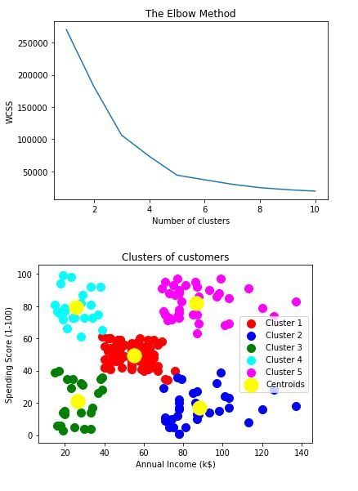

**Hierarchical clustering**

# Hierarchical Clustering

# Importing the libraries

import numpy as np

import matplotlib.pyplot as plt

import pandas as pd

# Importing the dataset

dataset = pd.read_csv('Mall_Customers.csv')

X = dataset.iloc[:, [3, 4]].values

# Using the dendrogram to find the optimal number of clusters

import scipy.cluster.hierarchy as sch

dendrogram = sch.dendrogram(sch.linkage(X, method = 'ward'))

plt.title('Dendrogram')

plt.xlabel('Customers')

plt.ylabel('Euclidean distances')

plt.show()

# Fitting Hierarchical Clustering to the dataset

from sklearn.cluster import AgglomerativeClustering

hc = AgglomerativeClustering(n_clusters = 5, affinity = 'euclidean', linkage = 'ward')

y_hc = hc.fit_predict(X)

# Visualising the clusters

plt.scatter(X[y_hc == 0, 0], X[y_hc == 0, 1], s = 100, c = 'red', label = 'Cluster 1')

plt.scatter(X[y_hc == 1, 0], X[y_hc == 1, 1], s = 100, c = 'blue', label = 'Cluster 2')

plt.scatter(X[y_hc == 2, 0], X[y_hc == 2, 1], s = 100, c = 'green', label = 'Cluster 3')

plt.scatter(X[y_hc == 3, 0], X[y_hc == 3, 1], s = 100, c = 'cyan', label = 'Cluster 4')

plt.scatter(X[y_hc == 4, 0], X[y_hc == 4, 1], s = 100, c = 'magenta', label = 'Cluster 5')

plt.title('Clusters of customers')

plt.xlabel('Annual Income (k$)')

plt.ylabel('Spending Score (1-100)')

plt.legend()

plt.show()

